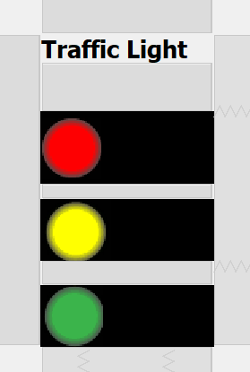

import java.awt.event.ActionEvent;

import java.awt.event.ActionListener;

import javax.swing.Timer;

public class Light extends javax.swing.JFrame { //Agamya

private final int nRed=10;

private final int nYellow=3;

private final int nGreen=10;

private int r,y,g;

private Timer timer;

public Light() {

initComponents();

red.setEnabled(true); //Agamya

green.setEnabled(false);

yellow.setEnabled(false);

start();

}

private void start(){

int speed=1000; // 1 second // Agamya

r =nRed;

y =nYellow;

g = nGreen;

ActionListener action =new ActionListener(){

public void actionPerformed(ActionEvent evt){

if(r>=0){

red.setText(String.valueOf(r));

r--;

}else if(y>=0){

yellow.setText(String.valueOf(y));

y--;

red.setText(null);

red.setEnabled(false);

yellow.setEnabled(true);

}else if(g>=0){

green.setText(String.valueOf(g));

g--;

yellow.setText(null);

yellow.setEnabled(false);

green.setEnabled(true);

}else

{

red.setEnabled(true);

green.setEnabled(false);

yellow.setEnabled(false);

green.setText(null);

r =nRed;

y =nYellow;

g = nGreen;

}

}

};

timer=new Timer(speed, action);

timer.start();

}

public static void main(String args[]) {

java.awt.EventQueue.invokeLater(new Runnable() {

public void run() {

new Light().setVisible(true);

}

});

}

private javax.swing.JLabel green;

private javax.swing.JLabel jLabel1;

private javax.swing.JLabel red;

private javax.swing.JLabel yellow;

// End of variables declaration

}

